Create a Website Part 1
Objectives
In this chapter you will:
- Learn about creating a website by watching a video
- Discuss new vocabulary about websites
- Set up a new account for creating your website
- Choose the design of your website.

Assignment Description
For this assignment, you will create a website for your business. So that you can learn how to create a website on your own, you will do this individually, not with your partner.

Preparation
Go to Weebly.com and watch the instructional video.

Discussion
Discuss the following questions with your group.
- What does “drag and drop” mean?
- What is a “cloud”?
- What were the two most interesting things you learned from the video?

Setting Up Your Website
- Go to Weebly.com
- Type your full name (first and last) into the Sign-Up box
- Type your email address into the Sign-Up box
- Type your password – use the same password you use for Gmail!
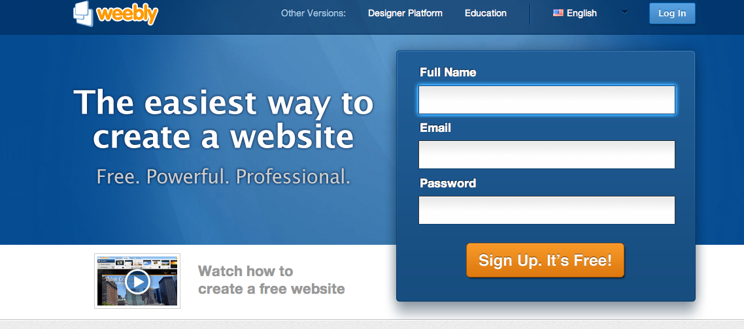
- Type the letters and numbers you see in the box on YOUR screen. This is used to verify that you are a real person and not a virus or a computer scam!
Type the exact letters and numbers you see into this box. Be very careful to type them EXACTLY like what you see!
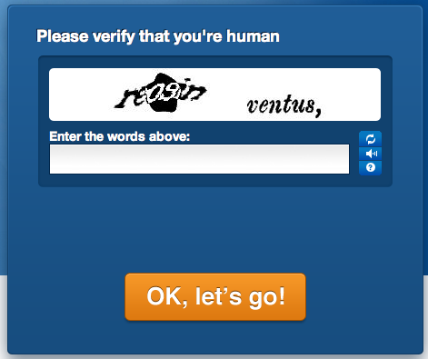

- Type the title for your website. For this exercise, type the name of your business.
- Choose “business” in the “Type of Site” box and “local” in the “category” box.
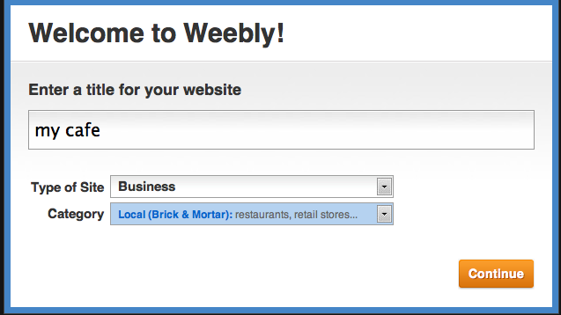

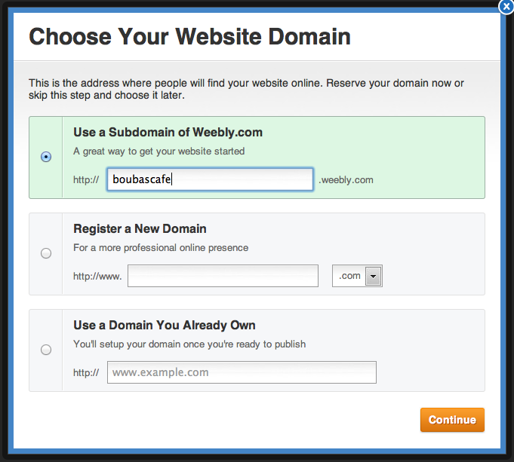
- Click on “Use a Subdomain of Weebly” – this means that your website will be free because Weebly.com is the owner!
- Type your name (no spaces) into the box – this will be your website address!

- Choose your design! Click on the Design tab and choose a design that you like.
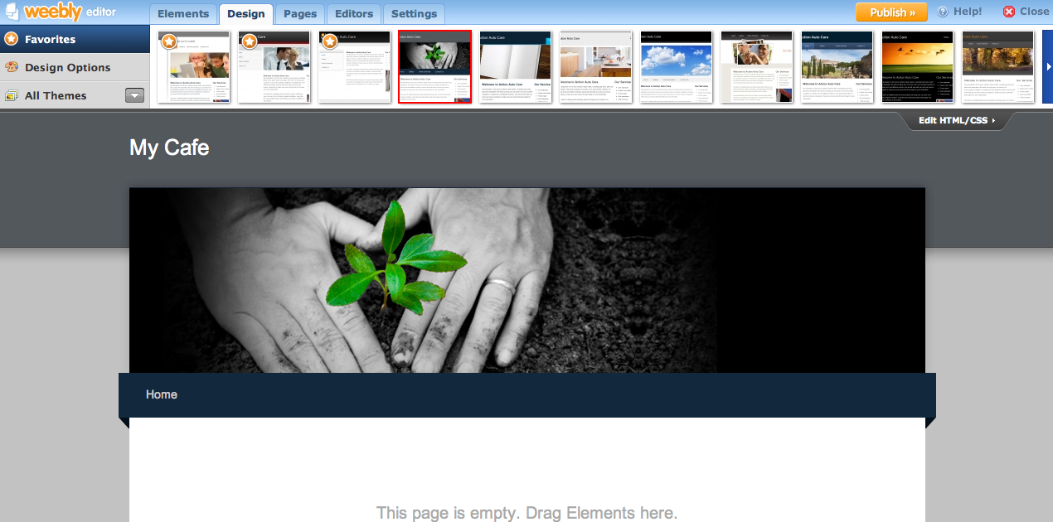
Now it’s your turn! Go to www.boubascafe.weebly.com to see an example!

