The Keyboard & Typing Tips

Objectives
In this chapter you will:
- Identify special keys on the keyboard
- Read about and discuss the functions of those special keys
- Discuss tips for proper typing posture and hand position
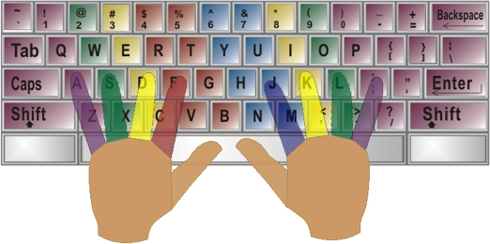

Keyboard Basics
The keyboard is used to input information into the computer.

Pre-Reading

Discussion

With a partner, try to DEFINE what you know about the following keys.

- Tab key
- Caps lock
- Shift
- Ctrl
- Alt
- Delete
- Backspace
- Home row keys
- Arrow keys

Vocabulary

Word | Definition
Cancel | To stop something
Character | A symbol (such as a letter or number)
To press | To push down
Command | To tell someone what to do
Posture | The position of your body while standing or sitting
Capital Letter | The uppercase or big form of each letter (Short form = Caps)
Escape | To get away from or out of someplace

Reading – Introduction to the Keyboard

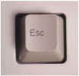  The escape key. Use it to cancel. It's very useful to get out of a place you do not want to be. |  |  | 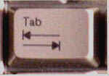 | The tab key. Use it to move the cursor over five spaces to the right.
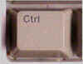 |  | The control key. Use it together with other keys for special commands. For example, when you type Ctrl + P, you will begin to Print. | 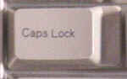 | The caps lock key. Use it to change small or lower case letters into big or capital letters. Remember to turn it off when you are done.
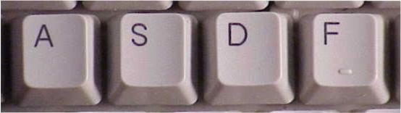  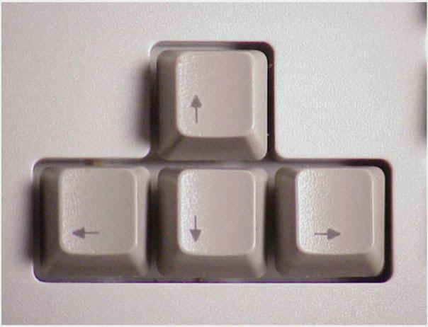  The arrow or directional keys. Use them to move around on the screen and in your documents. |  |  | The left shift key. Use it to change one letter from a lower case or small letter into a capital or big letter. It also lets you type the symbols above the numbers. For example, if you press SHIFT and 4, you will see the $ sign.  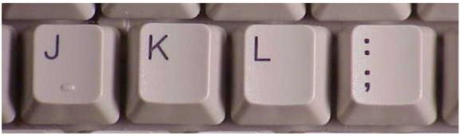
 | The home keys. Your fingers should rest on these keys when they are not typing other letters or numbers. The left hand rests on FDSA, and the right hand rests on JKL;.
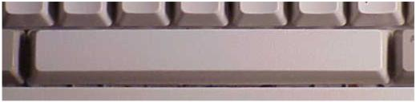

The space bar. Use it to put spaces in your document. Use your thumbs on the space bar.

The delete key. Use it to erase or delete letters and numbers to the right of the cursor | 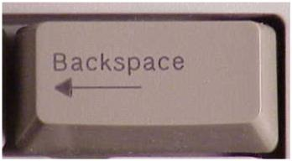  The backspace key. Use it to erase or delete letters and numbers to the left of the cursor. If you hold it down, it will erase quickly.
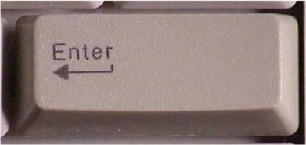  The enter key. Use it to enter a command or to go down a line in a document. | 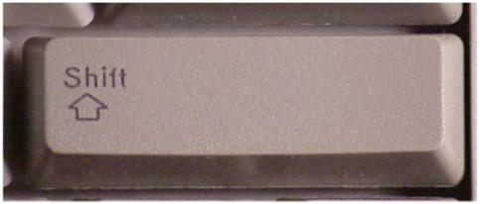  The right shift key. It works just like the left shift key. Use it to change one letter from a lower case or small letter into a capital or big letter. It also lets you type the symbols above the numbers, like the $ sign above the 4.

Task 1 – Label The Key
Directions:

Write the name of each key of the keyboard under the picture.

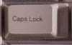 | 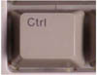 | 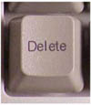
Caps Lock Key
 |  | 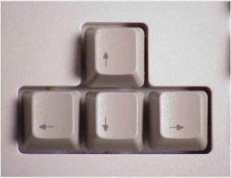

Task 2 – Connect The Keys
Directions:

Draw a line from each key to its location on the keyboard.

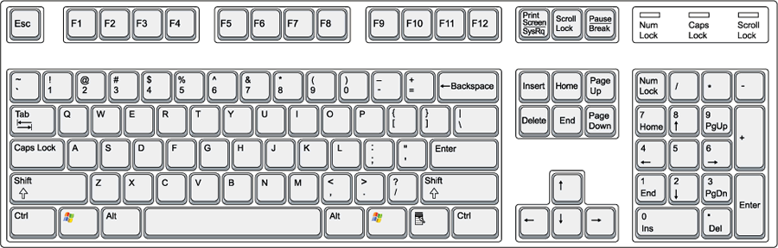

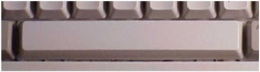

Task 3 – Fill In The Blanks
Directions:

Match the keys with their descriptions.

A | B | C | D
E | F | G | H
I | J | K | L
K_ 1. The key to remove letters to the left of the cursor.
___ 2. The keys used to move the cursor around the screen.
___ 3. The key to remove letters to the right of the cursor.
___ 4. The key used to make spaces between words.
___ 5. The keys where the left hand should rest.
___ 6. The key used to make all letters into capitals.
___ 7. The key used to move down on the screen and put in an extra line.
___ 8. The key that also acts the same as a cancel button.
___ 9. The keys where the right hand should rest.
___ 10. The key that moves the cursor over about five spaces.
___ 11. The key used with a letter key to make one letter into a capital.
___ 12. The key used with other keys to do special jobs like printing.

Typing Tips
Here are some tips about typing on a computer keyboard. Practice keyboarding everyday and follow these tips to increase your typing speed and accuracy.

1. Posture
- Sit up straight in your chair.
- Keep your back straight.

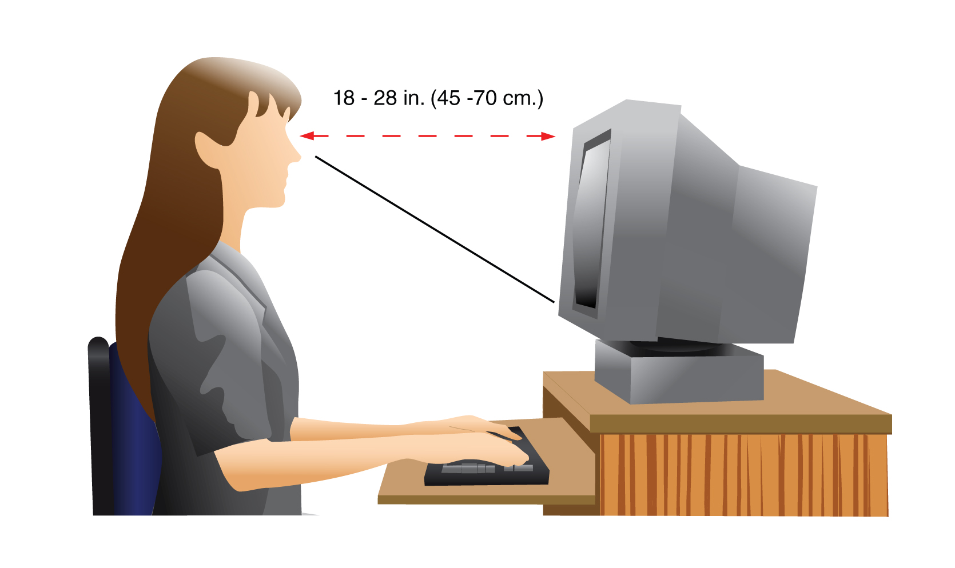
2. Eyes
- Keep your eyes on the text you are typing or on the monitor.
- Do not look at the keyboard!

3. Hands
- Keep your fingers curved.
- Keep the heels of your hands just above the keyboard.

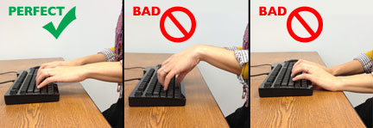
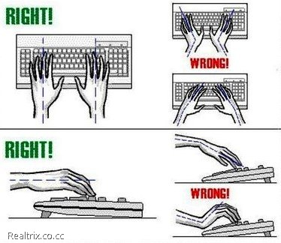

4. The Home Row
- Keep your fingertips on the home row keys.
- Move your fingers to other keys when you need to. Then move them back to the home row.
- Use your thumb to press the spacebar.

5. Special Keys
- Use your right pinky finger to press the ENTER key.
- Use your right pinky finger to press the BACKSPACE key.
- Use your left pinky finger to press the TAB key.
- Use your left pinky finger to press the CAPS LOCK key.
- Use your right and left pinky fingers on the SHIFT KEYS to capitalize letters.

More Typing Tips

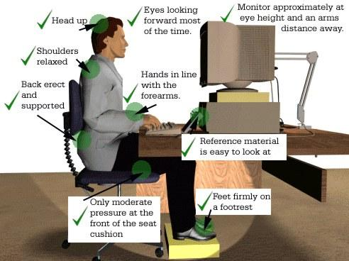

Task 4 – Keyboard Practice

Directions:

In this exercise you will practice using the special keys that we have learned so far. Follow these instructions carefully!

Part 1: Practice the Enter, Delete and Backspace keys

- Open Microsoft Word (follow the teacher if you need help)
- Type your name – press the Enter key. What happened to the cursor? ________________________.
- Type your favorite color – press the Enter key.
- Click your mouse to the left of your favorite color. Use the Delete key to erase your favorite color!
- Click your mouse to the right of your name. Use the Backspace key to erase your name!

Part 2: Practice the Shift, Caps Lock and Tab keys

- Type your name again and use the shift key to capitalize the first letter of your name. Press the Enter key to go to the next line.
- Press the Caps Lock key (check to make sure the light in your keyboard is on). Type your favorite color. Press the Enter key to go to the next line.
- Press the Tab key. Where did the cursor move to? ____________________
- Press the Tab key again. Where is the cursor now? ____________________

Part 3: Practice typing

Type a short paragraph about yourself. Include where you are from, your favorite hobby, your family, and what you enjoy doing in your free time. Practice keeping your fingers on the home keys and follow the typing tips we have learned so far.

