Introduction to PowerPoint – Part 1

Objectives
In this chapter you will:
- Compare and find similarities between MS Word and MS PowerPoint
- Read about features in PowerPoint.
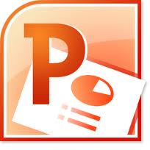
- Use features in PowerPoint including slide layout, slide design, and slide show view.
- Create a presentation about yourself and your home country.

MS PowerPoint Basics
PowerPoint is software that lets you create presentations.

Pre-Reading

Discussion
Define what you remember about MS PowerPoint from what we’ve learned so far.

- Open MS PowerPoint.
- Look at the Tabs and Groups. Click on all the Tabs.
- How are the Tabs and Groups similar or different from Word?
- How is the Status Bar similar or different from Word?
- How is the Title Bar similar or different from Word?
- What do you think you will be able to do in this software program?

Vocabulary

Word | Definition

Reading – Introduction to Microsoft PowerPoint Window
Microsoft PowerPoint is software that is used to create slideshow presentations. When you work in PowerPoint you are making slides. When you put a group of slides together you have a slideshow. Most PowerPoint slides have text and graphics. You can also add movement and sounds to your slides.
Many businesses and schools use PowerPoint. Teachers use PowerPoint for instruction. Students use PowerPoint for presentations. Business people use PowerPoint for meetings and employee training.

A. The Slides Tab
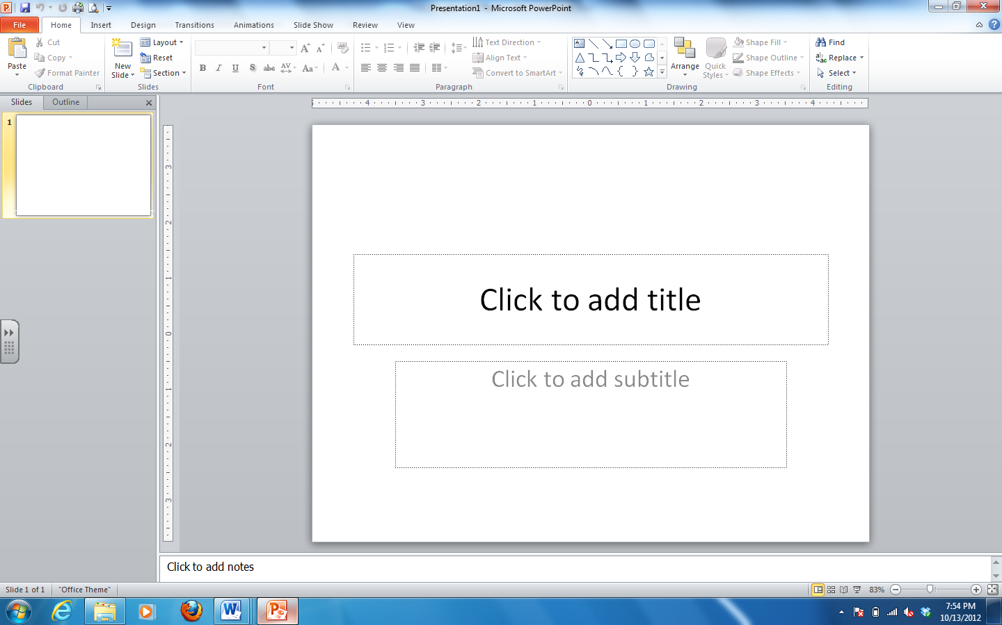
The slides tab is in the left part of the window. It displays all of the slides you currently have in your presentation.

B. Outline Tab
The outline tab is also in the left part of the window. It displays an outline of your presentation that shows just the titles of each slide.

C. The Ribbon
Like the Ribbon in MS Word, the Ribbon in PowerPoint has Tabs and Groups.

E. The Status Bar
Like the Status Bar in MS Word, the Status Bar in PowerPoint gives you information about your presentation. It tells you how many slides it has. It also has the + and – buttons that allow you to zoom in or out.

Also on the Status Bar is a choice of how you want to view your presentation. You can choose from the following:
Normal view button the view you want to be in when you are working on your slides.
Slide Sorter view button the view you want to be in when you are changing the order of your slides or adding transitions to your slides.
Reading view button the view you want to be in when you are reading your slides.
Slide Show view button click on this button when you are ready to view your slide show.

Normal View
Slide Sorter View
Slide Show View
Reading View

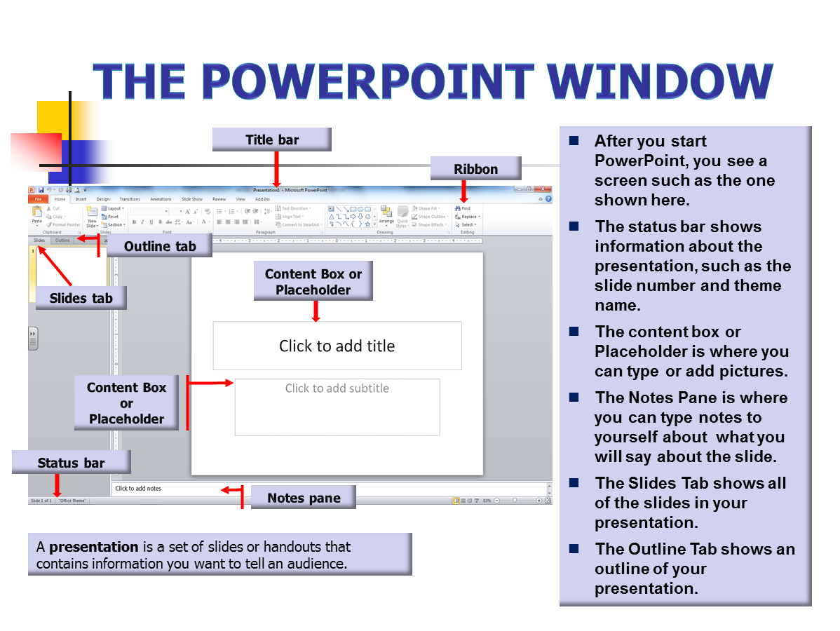

Your First Presentation – All About Me!

Task 1 – PowerPoint Assignment
Directions:
In this assignment, you will create your first PPT presentation! The topic of this presentation will be about the thing that you know best – YOU! That’s right, you will create a presentation about you: where you are from, what you like to do, what you like to eat, your family, and more!

A. Open PowerPoint and Save your File
- Open PPT from the Start Menu
- Save your file in your H: Drive
- Name your file: All About Me.

B. Make Your Title Slide
- In the Placeholder “Click to Add Title” box, type: All About Me
- In the Placeholder “Click to add Subtitle” box, type: By [your name]

C. Add a New Slide – Favorite Food
- Click on the Home Tab and find the Slides Group
- Click on the down arrow of the New Slide command
- Click on the Two Content layout
- In the Placeholder Title Box, type My Favorite Foods
- In the left Placeholder Content Box, type information about three of your favorite foods
- Go to Google Images and find a picture of ONE of your favorite foods
- Save the picture to your H: drive. Be sure to rename it!
- Go back to your PPT presentation
- In the right Placeholder Content Box, click on the Insert Picture icon
- Find your food picture and insert it

E. Add a New Slide – Home Country
- Click on the down arrow menu of the New Slide command.
- Click on the Title and Content layout
- In the Placeholder Title Box, type My Home Country

F. Change the Layout of a Slide
- In the Home Tab Slides Group click on the Layout command drop down menu
- Change the layout to the Two Content layout.
- Type information about where you are from in one Placeholder or Content box.
- Find a picture of your home country to insert in the other Placeholder Content box.
Now you know how to change the layout of a slide and add a new slide. Continue creating at least three more slides with the following titles:
- My Family.
- My Hobbies
- My Goals for This Class.
When you finish these slides, create more! We want to know ALL about you! Tell us about your job, what kind of job that you would like, places that you have lived, and anything else you would like to share.
SAVE your File!

Task 2 – PowerPoint Review

Part 1
In this assignment, you will label all of the following items on the picture above
- Content Box or Placeholder
- Slides Tab
- Outline Tab
- Ribbon
- Status Bar
- Slideshow view button
- Normal view button
- Slide sorter view button
- Reading view button
- Title bar
- Title Slide
Part 2
In this Assignment, you will define, in your own words, how you use each of the following items. One example is included below:
Content Box | The content box is where I insert text or pictures or images onto my slide.
Slides Tab
Ribbon
Status Bar
Slideshow view button
Normal view button
Slide sorter view button
Title bar
Title Slide
MS PowerPoint – Design Gallery

Task 3 – PowerPoint Design Gallery Review
Directions:
In this assignment, you will continue to work on your PPT presentation. You will learn how to use the Design Gallery.

A. Open your PPT presentation “All About Me”
- Click on the Start Menu button
- Click on Computer
- Double click in your H:Drive
- Open your “All About Me” PPT presentation

B. Use the Design Gallery
- Click on the Design Tab and find the Themes Group
- Use the Drop Down Menu to choose a slide design that you like the most
- Notice that ALL of your slides change when you choose a slide design.

Save your File!

Slide Organization & Slideshow

Task 4 – PowerPoint Slide Organization & Slideshow Review
Directions:
In this assignment, you will continue to work on your PPT presentation. You will learn how to organize your slides and view your slideshow.

A. Open your PPT presentation “All About Me”
- Open PPT from the Start Menu
- Click on Computer
- Double click on H:Drive
- Open your “All About Me” presentation

B. Organize your Slides
Slide Sorter View button
- Click on the Slide Sorter View button

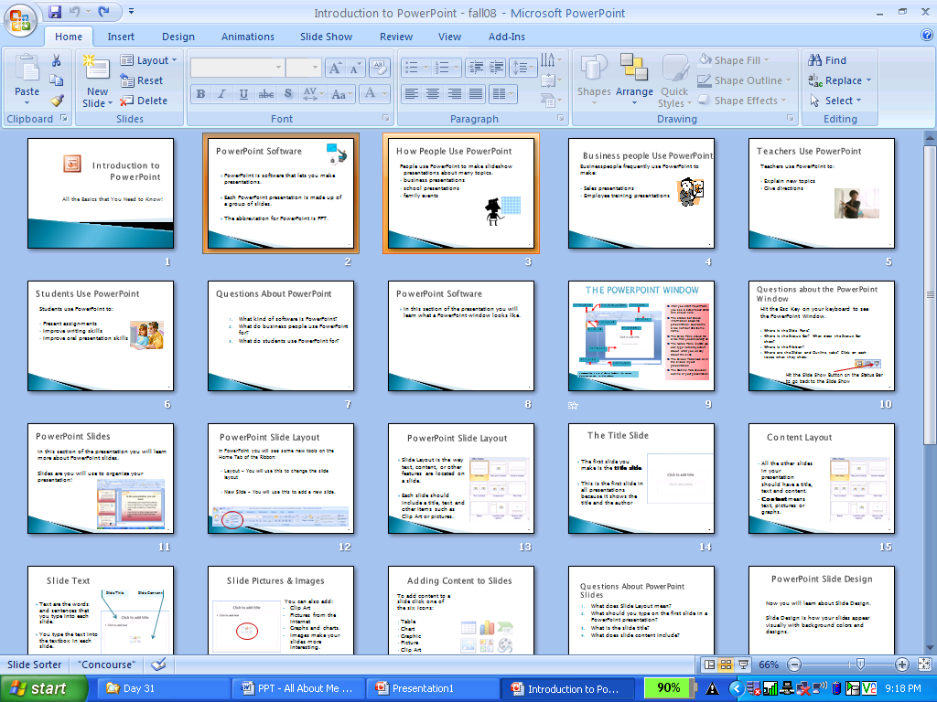
- Your window will show all of your slides. To move a slide, click and drag it to another location.

- Move “My Favorite Food” to be AFTER “My Home Country”

C. View Your Slideshow and Practice your Presentation!
- Click on the Slide Show View button
Slide Show View button

- Practice what you will say about each slide. Use your ARROW KEYS to move between your slides.
- To view your PPT Window, hit the Esc key.

Task 5 – PowerPoint Slide Organization & Slideshow Review
Direction:
Open MS PPT. Discuss the process and do each of the following items.
- Add a new Slide.
- Change the layout of a slide.
- Add a picture to a slide.
- Cut your picture and paste it to a different slide. Write down three different ways to cut/copy and paste.
________________________________________________________________
________________________________________________________________
________________________________________________________________
- Save your presentation to your personal folder
- Go to the Slide Sorter View. Reorganize your slides
- Go to the Slideshow View. Write down three different ways to get to Slideshow
______________________________________________________________
______________________________________________________________
______________________________________________________________

Task 6 – Fill in the Blanks
Part 1:
Read the MS PPT vocabulary items in the section below. Then choose the best word for each sentence and write the answer in the blank.

Slide Show Title Content
Design Slides Presentation
Layout Title Slide

- In order to show your presentation to an audience, you must use the _________ _________ view
- The way a slide appears visually with background colors, textures or pictures is the slide _________.
- The way text, content, or other features are organized on a slide is the slide ____________.
- The first slide in any presentation is the _________ _________ because it uses the ___________ layout.
- PPT presentations are organized by ________________.
- PPT is ________________ software.
- Text, images and pictures are all examples of slide _____________.

