Introduction to MS Excel

Objectives
In this chapter you will:
- Identify parts of the spreadsheet window
- Understand what a worksheet is and why to use one.
- Use the fill tool to automatically enter data
- Change the column width and row height
- Use the Autosum feature to calculate a total amount.
- Create a home expenses spreadsheet.

MS Excel Basics

Discussion – Open MS Excel
- Look at the Tabs and Groups. Click on all the Tabs.
- How are the Tabs and Groups similar or different from Word?
- How is the Status Bar similar or different from Word?
- How is the Title Bar similar or different from Word?
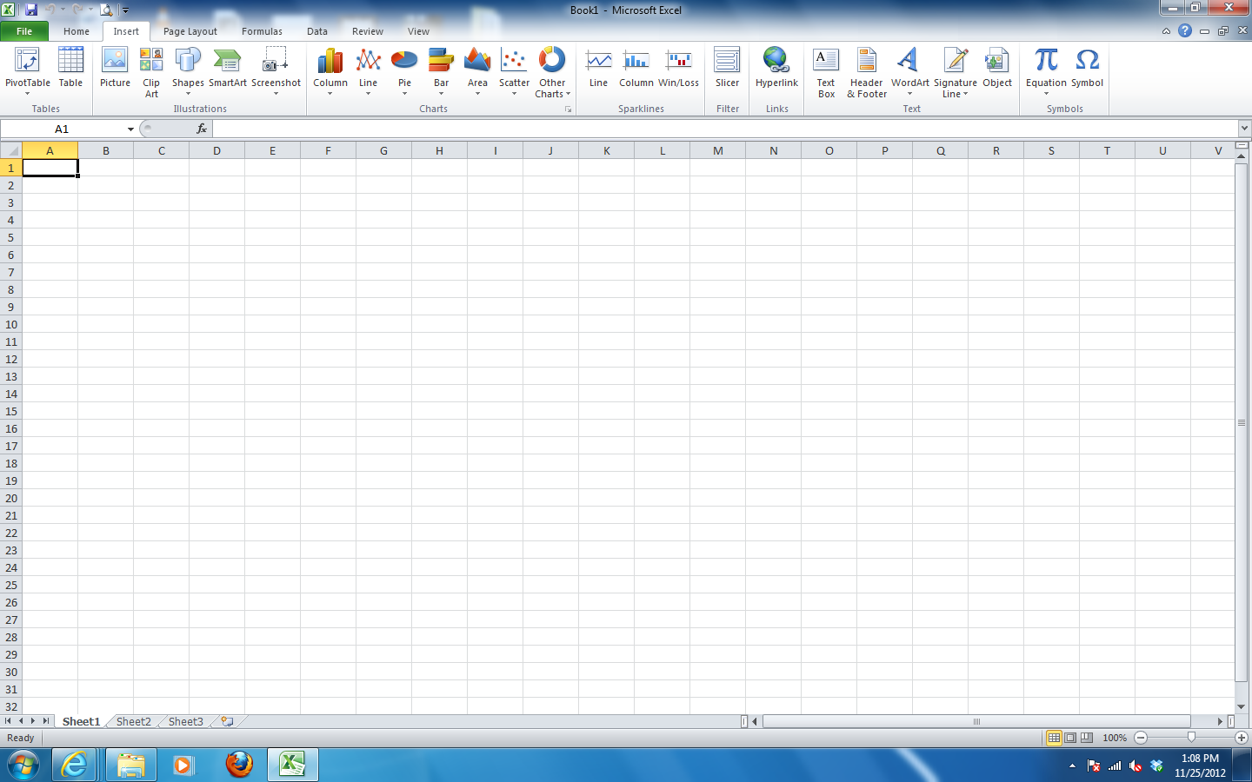
- Label the parts of the window below that you know already.

Elements of a MS Excel Window
H
G
E
B
C
F
A
A: Name Box
B: Formula Bar
C: Cell
D: Sheet Tab
E: Worksheet
F: Active Cell
G: Column
H: Row
D

Introduction to Excel
Excel is a software program that can be used to perform calculations. It is commonly called spreadsheet software. We use the word spread because the worksheets are very long and can spread across 2 or more pages. Spreadsheets are organized by cells. A cell is the intersection of a row and a column. There are rows of cells and columns of cells.
The Name Box is in the upper-left hand corner of the spreadsheet, just below the ribbon, indicates the cell where your cursor is located. When you open a spreadsheet, the default location will show "A1," for example.
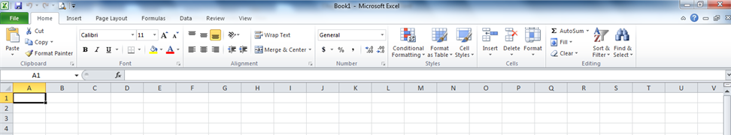
The Formula Bar in Excel is located above the work area of the spreadsheet. The formula bar displays the data or formula stored in the active cell. The formula bar can be used to enter or edit a formula, a function, or data in a cell. If cell A1, for example, contains the phrase "John Smith," the formula box will display the phrase "John Smith." If the cell contains a formula, even though the cell displays the formula's results, the formula box shows the formula itself.
Cell is a box where a column and a row meet! The address of a cell is the column letter and the row number. The first cell in a worksheet is cell A1. Notice that the column letter comes first! In each cell, you will only enter one piece of information.

Active Cell is known by its black outline . Data or information is always entered into the active cell. Different cells can be made active by clicking on them with the mouse or by using the arrow keys on the keyboard.
Sheet Tabs are the tabs at the bottom of a worksheet in which tells you the name of the worksheet - such as Sheet1, Sheet2 and Sheet3. By default every workbook has 3 worksheets. Switching between worksheets can be done by clicking on the tab of the sheet you wish to access.
In order to create a new worksheet you can click on insert worksheet or use the short cut Shift + F11

Worksheet is a single page or sheet in a spreadsheet program such as Excel. Remember by default every workbook has 3 worksheets.

Columns are vertical on a worksheet and each one is identified by a letter in the column header. In this picture, Column B is highlighted.

Rows are horizontal on a worksheet and each one is identified by a number in the row header. In the picture below, Row 4 is highlighted.

Remember you can tell what cell you have clicked on because it will have dark lines around all four sides. This is called your Active Cell. You should also notice that the column and row are highlighted for any active cell that you click on. Each cell in a worksheet has a Cell Address that is the column letter and the row number.

So what is the cell address in the picture above? ____________________
What is the cell address in the picture below? _______________________
In order to work on an Excel spreadsheet, the cursor will change into different shapes. Below are some examples
Shape | Where you find it | What it does
 | The default pointer shape in Excel. | You can highlight cells with this pointer
 | Appears when the pointer is on the border of a window and your window is NOT maximized | Adjusts / resizes the window
 | Appears when the pointer is between a row or column divider | Adjusts height and width of rows and columns
 | Appears when you are editing cell contents / typing | Provides a text insertion point where you can begin typing
 | Appears when the pointer is on a column letter or a row number | Highlights an entire column or row
 | Appears when the pointer is placed over a cell border/edge, the edge of a chart, or the edge of a picture | Moves cells, charts, or pictures
 | Appears when the pointer is on the "fill corner" of a cell or cell range, it is called the Fill tool | Automatically Fills other cells with similar information
 | Appears when mouse is placed over the Ribbon | The standard Microsoft Windows pointer; selects Ribbon and menu tools

Task #1
Identify all the different cursor shapes in excel, by moving the cursor around in the worksheet or spreadsheet.

Moving around the worksheet
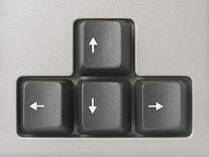
In order to move around the worksheet you can use the arrow keys on the keyboard.

You can also select the cell where you would like to work by using the left click on mouse.

Selecting Cells
When the cursor is inside of a worksheet it changes into a white cross, you can use it to select on any cell on your worksheet, from there you can either format the cell or add data to the cell. You can also use your mouse to select or highlight a range of cells by dragging the mouse over the cells that you would like to select. When you finish selecting your cells, make sure you let go of the mouse button.
When you select a range of cells, for example, from B2 to B11 they would be presented by B2:B11.

In order to add data or content into a cell, select the cell and start typing. You can
press the enter key to move to the cell below or the Tab key
to move to cell to the right.

Formatting Cells
You can use the commands and shortcuts on the Home Tab to change the way the data inside the cells is displayed by using Font, Font Size, Font Color, Alignment, etc.
Also, by clicking on the button with the $ will format all selected cells which contain numbers to be displayed with a dollar sign and two decimal places.
Likewise by clicking in the drop down menu on the Number Format command in the Number group, you have access to more choices, like formatting dates and more number formatting options.

Moving and Copying Cells
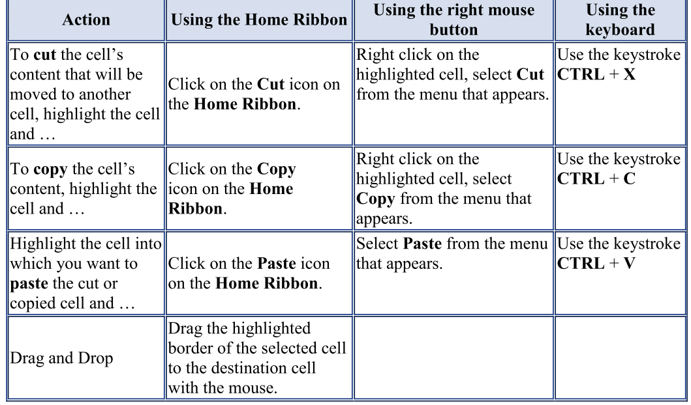
Cut, copying and paste the cell content can be really simple, just follow the instruction from the table below.

Resizing Columns and Rows
There are several ways to resize a Column and a Row
- Resize a Column by dragging the black cross with two arrows to the right or left
- Resize a Row by dragging the black cross with two arrows up and down - OR
- Click on the Home Tab Cells group Format command drop down menu, which will allow you change the Column Width or Row Height. – OR

- Select the Column and then double click on the black cross with two arrows located on the line separating the two columns, this will make the column as wide as it currently needs to be.
- Select the Row and then double click on the black cross with two arrows located on the line separating the two rows, this will make the row as big as it currently needs to be.

Inserting a Column and a Row
Highlight the cell, column, or row where you would like to insert. Click on the Home Tab Cells group Insert Command Drop Down menu and select Inset Sheet Column or Insert Sheet Row.

Formulas
What it makes unique about spreadsheet programs such as Excel is that it allows you to create mathematical formulas and execute functions. Otherwise, it is not much more than a large table for displaying text.
Formulas are entered in the worksheet cell and must begin with an equal sign “=”. You must enter an equal sign as the first character in the cell in order to let Excel know that what you are creating is a formula and it is not just a number or a word.
After typing the equal sign you will select or type the cell address where the first value is located and then type the symbol of the operation that you would like to perform such as addition, multiplication, division and subtraction. Then select or type the cell address of the next value that you will need and press the Enter Key when you finished. Do not forget, you do NOT need spaces in the formula.
Let’s practice on a piece a paper before you start working on MS Excel.
- In Column C add the values from Columns A and B
- In Column D multiply the values from Columns A and B
- In Column E divide the values from Columns A with B
- In Column F subtract the values of Column B from Columns A
=A3+B3
=A2*B2
=A2/B2
=A2-B2
=A2+B2

Functions
Instead of manually typing a formula into the formula bar, you can use the Formula Tab to insert common functions such as Sum, Average, Count, Max, Min, etc.
- Select the cell where you want the result of the function
- Click on Home Tab Editing Group Sum command drop down menu
- Click on the function you would like to use such as Sum, Average, Count, Max or Min. Select the range of cells with the values that you need for your function
- And press enter.

AutoSum
The AutoSum command helps by suggesting a range of cells that Excel thinks might be important for you. You can always edit the suggested range.
- Select the cell where you like the result
- Click on Home Tab Editing Group AutoSum Command
- MS Excel will suggest a range of cells

- If the range is correct, press Enter
- And the final result will be displayed, like in the picture below.

Now, as a practice copy the values in Column A and B and exercise the AutoSum function.

Autofill
The Autofill allows you to quickly fill cells with repetitive or consecutive data such as chronological dates or numbers and repeated text.
- Type the beginning number or date or text that will be repeated into a cell
- Select the Fill Tool at the bottom, right corner of the cell with the left mouse button and drag it down as many cells as you want to fill

- Release the mouse button
Now, practice using dates or days of the week or numbers.

