Introduction to Email – Part 2

Objectives
In this chapter you will:
- Discuss the basic tools that you are using in your Gmail account.
- Learn how to Attach a file to an email and send it.
- Learn how to Download a file attachment and open it.
- Learn how to use Contacts.
- Create a Contacts group.

EMAIL BASICS REVIEW

Review
Answer the following questions and then compare answers with your partner.
- When you see this
  - What do you type into the Username box? ______________________
  - What do you type into the Password box? _______________________
- You meet a new friend and you want to give him your email address. Write down your email address here _____________________________________.
- Label and briefly describe the following items on the picture below: To Box, Subject Box, Message Box, Inbox, Compose Button. The first one is done for you as an example.
To Box. This is where I type the recipient’s email address.
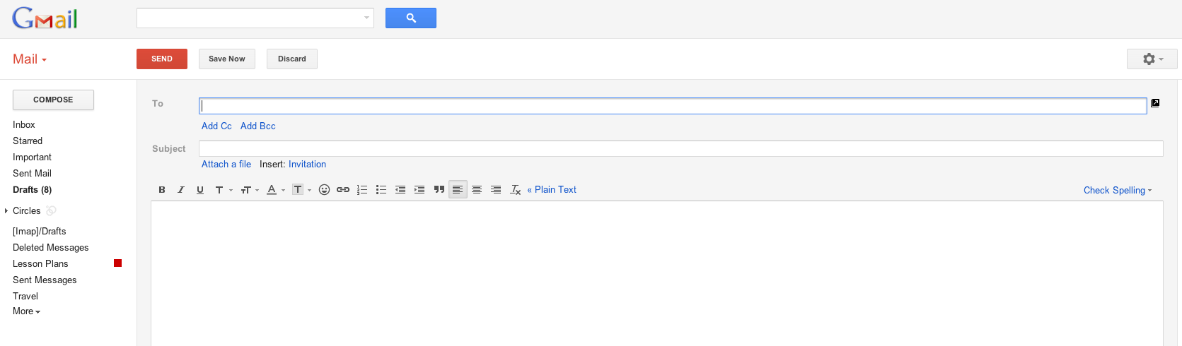

ATTACHING A FILE

A “File” is anything that you have created on your computer. A file can be a Word document, a PPT presentation, a digital picture, or an Excel spreadsheet. And you can send a file by email to anyone! Here’s how to do it.

- Go to your Gmail account and Compose a new message.
2
1
3
- Enter the email address of the recipient in the To box
- Click on “Attach a file” - A dialog box will open
This dialog box is asking you WHERE to find your file. At school, we save all of our files under COMPUTER H Drive.
When you are at home, you have to remember where your files are saved!

- Find your file in Computer Double click on your H: Drive
4
- Double click on the icon of the file you want to attach.
6
5
- Click on “Open” to attach the file.
At this point, you will know that the file is attached because you will see the file name, the file size, and a check mark next to it. Do you see all of those items? You will not see anything else!
To attach more files, click on “Attach another file” – you can attach many files!

- Type the subject or title of the message on the Subject Box.
- Type something in the message box about your attachment.
7

8

- Send the message!

PRACTICE TASK
- Send an email to your teacher and the teacher’s assistant - One message! Use a comma to separate the email addresses.
- Attach your Hobbies Word document that you saved in Computer H: Drive.
- DO NOT forget to use the Check Spelling tool before you send the Email.
3

DOWNLOADING A FILE

To “download” a file means to transfer or copy the file from the Internet to your computer. When you download a file from Gmail, click on the “Download” link, NOT the “view” link. “View” only gives you a temporary look at the file, it does not transfer the file to your computer! Below are the steps to download

- Go to your Gmail account and look for a message with an attachment. You will know that a message has an attachment because it will have a paper clip next to the time!
1
2

- Open the email.
To Box

- Click on “Download” next to the name of the file
3
- Click on Open
4

EMAIL CONTACTS
Email contacts are addresses that you use frequently or purposely save to your account.

- To find your contacts, click on the “GMAIL” button in top, left corner of your screen.
1

- You will see that “Contacts” is listed as an option, click in the Drop Down Menu and Click on Contacts.
2

- Explore the options. You will see “Most Contacted” and “Other Contacts”. What do you see under these links?
3

Create a Contacts Group
- Put your cursor over “New Group” and click on the link to create a “New Group”.
A Contacts Group will allow you to send an email message to the group and the only thing you have to type in the To Box is the group name! You don’t have to type any email addresses! Isn’t that great?

1

- Enter the name of your contacts group. For this exercise, name it “classmates”
1
2

- Click on the My Contacts link and you will see your “classmates” group.
When you click on your “classmates” group you will see that it is empty!
Let’s add some email addresses to it – okay?

- Click on the Most Contacted link so that you see all of the email addresses you use most frequently.

4

- Look at the picture above and notice two things: 1 – there are check marks next to two addresses, and 2 – a new icon has appeared above the list. This icon is the “Groups” icon!

- Put a check mark next to the email addresses you want to put into your group.
- Click on the “Groups” icon and put a check mark next to the group “Classmates” you want and click apply.
- Now go back to your Inbox by clicking on the Drop Down Menu “Contacts” and choosing “Gmail”.
- Click on Compose and compose a message to your group. In the To Box, just type your group name!
- Press the enter key.
- You will be able to see in the To Box all you contacts that you create in the Classmates group.
- Type the Subject or Tittle of your Email in the Subject Box.
- Type a informal message on the Message Box to your classmates
- Send it.

EMAIL REVIEW TASK
Use the following words to complete the sentences below:
Download Attach Contacts Paper Clip Group

- If I want to send a Word document to my friend, I can _____________ it in an email message to her.
- When my teacher sends me an attachment I have to ______________ it in order to open it.
- I know that there is an attachment in an email because I see the _____________ __________.
- I can see all of my _________________ by clicking on the “Contacts” button
- Creating a Contacts _____________ is very easy!

