Introduction to Email – Part 1

Objectives

In this chapter you will:

1. Read about how email works
2. Learn vocabulary you can use to describe what you do in email
3. Learn how to write an email and reply to an email

MCj04136680000[1]

Email Basics

# Pre-Reading

## Discussion

1. Tell your partner about any experience you have with email. Do you use an email account currently?
2. Talk with your partner about what you know about the words in the list below:

* Username
* 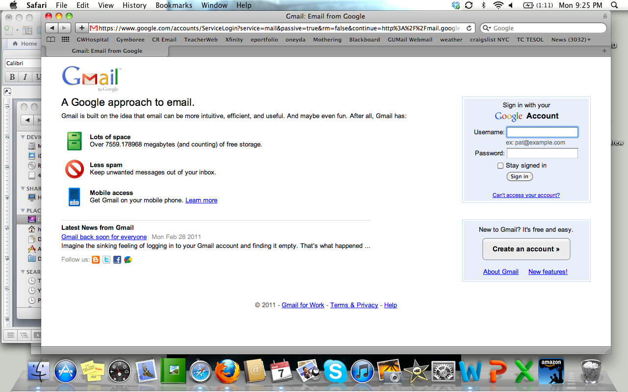Inbox
* “To” box
* Subject box
* Message box
* Sender
* Recipient
* Reply

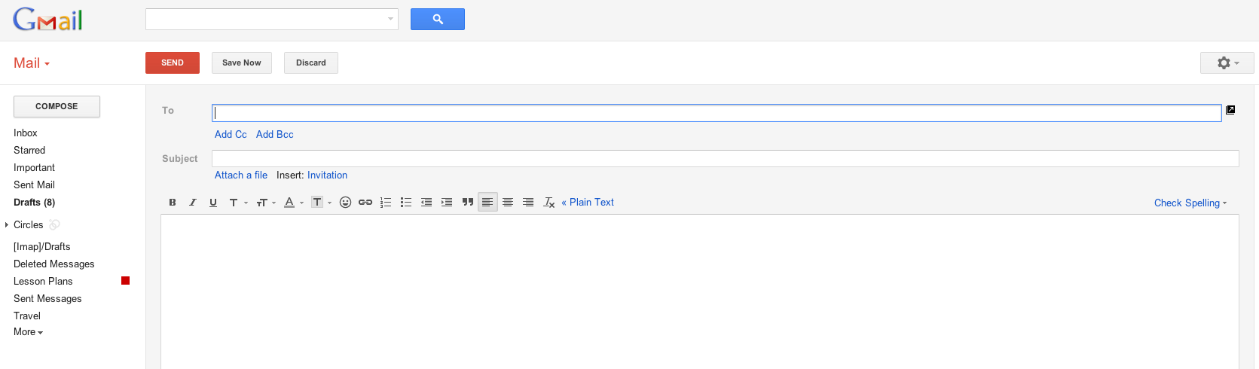

# Reading – Introduction to Email

Email means electronic mail. It is mail that you send using the Internet. There are many companies that provide email – they are called Email Providers. Some popular Email providers include:

* Hotmail
* Yahoo
* Gmail

So why should you use email? Using email, you can send a message any time and anywhere that you have Internet access. You can also send the same message to several people at the same time.

When you have an email account you have to use a **username** and password. Your username is the first part of your email address. As an example, Janett’s email address is below. The username is everything before the @ (“at”) symbol.

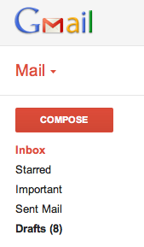 [jarandia@gmail.com](mailto:jarandia@gmail.com)

When you write an email message you are called the **Sender**. When you want to start a new message in Gmail, you have to click on the “**Compose**” button. “Compose” means to write! Find the compose button on the picture to the right.

The person who receives the email is called the **Recipient**. You can send email to more than one recipient at a time.

On the next page is a picture of what you see when you begin to write an email message. Look for the **to box**, the **subject box**, and the **message box.**



Message Box

To Box

Subject Box

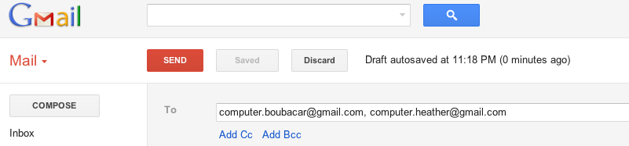The To Box is where you type your recipient’s email address. If you want to send the message to more than one person, use a comma (,) to separate the email addresses. Here’s an example:

Notice that there are two email addresses and that there is a comma between them.

In the Subject box you will type the subject of your email. For example, if you are sending a message to a friend about plans for the weekend, your subject might be “weekend plans”!

In the message box you will type your message. Always begin with a greeting like “hello” or “hi”. If your email needs to be more professional, use a greeting like “Dear Mr. or Mrs.” And always end your message with a salutation. Some examples of informal salutations include:

* See you soon!
* Cheers
* Ciao
* Hugs
* Love

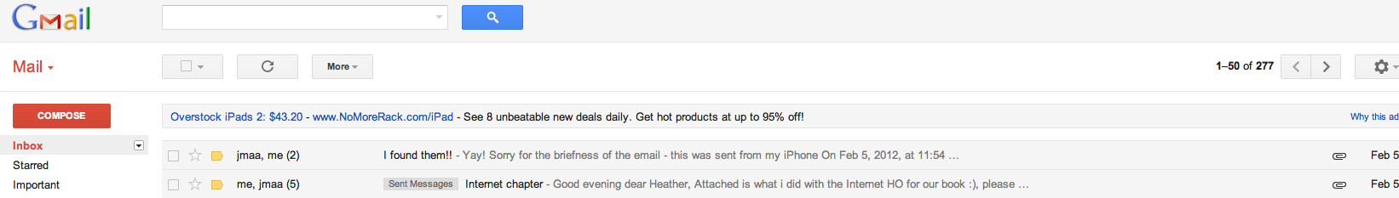When you receive email, you will see it in your **Inbox.** To read a message, just click on the Sender OR the Subject line of the message.

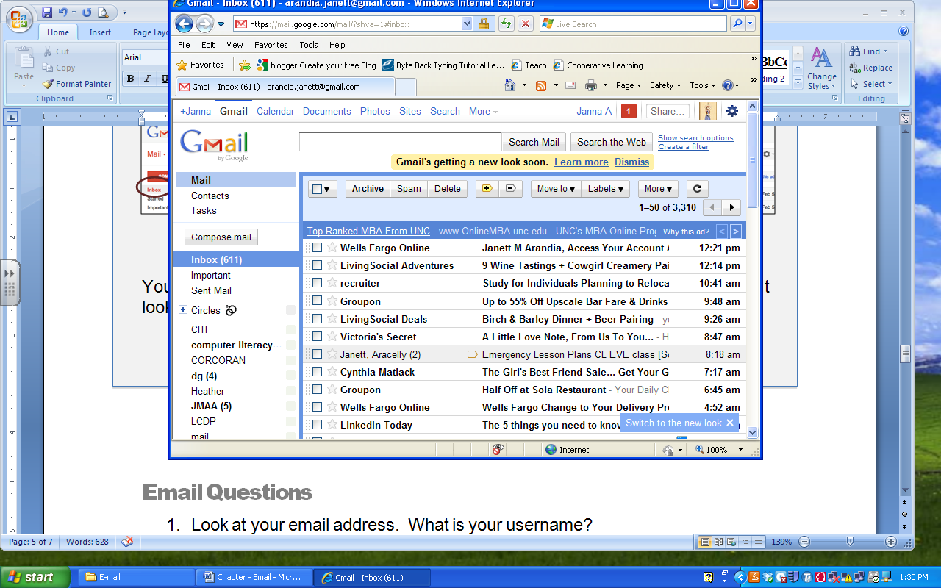

You can reply to email messages that you receive – just click on the Reply Button. It looks like this:

# Email Questions

1. Look at your email address. What is your username?
2. What button do you click on to begin writing an email?
3. What do you type in the To Box?
4. What do you type in the Subject Box?
5. Who is the Recipient?
6. Where do you find your email messages?

Gmail Review Task

The purpose of this task is to review how to log into your Gmail account. Save this handout and use it whenever you forget!

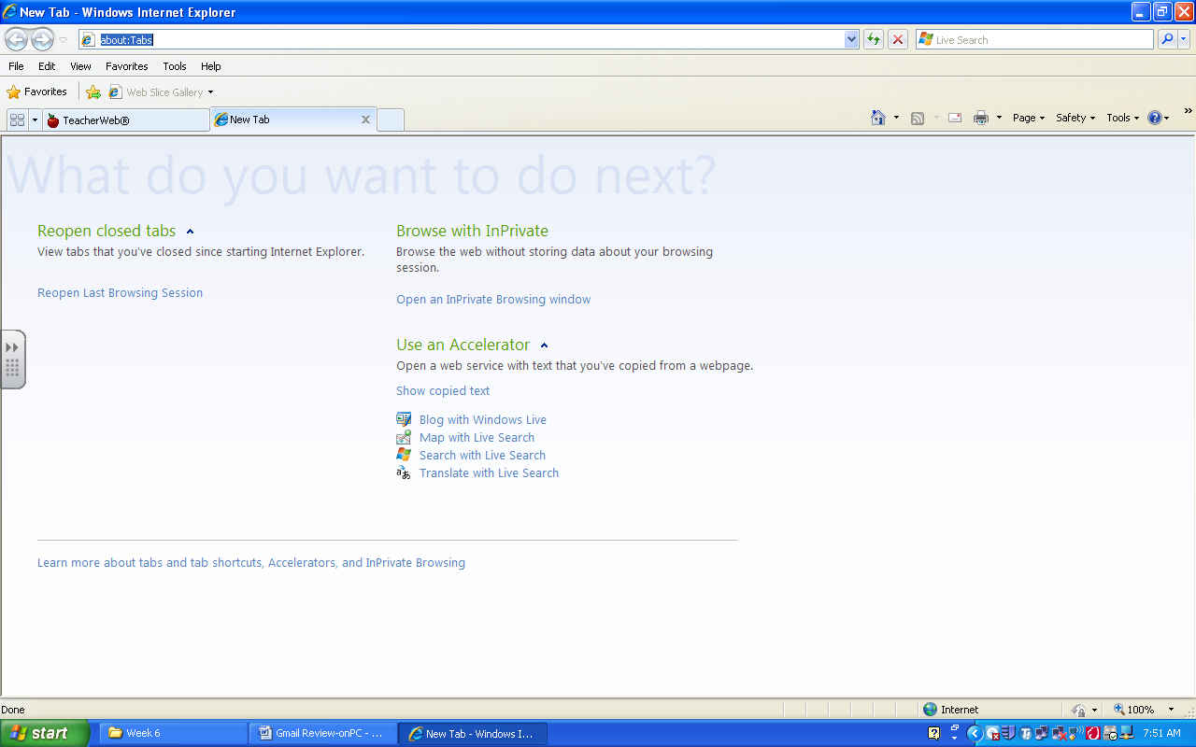

# LOGGING INTO GMAIL (Fill in the blanks!)

1 – Type _______________________________ into the address bar.

2 – Type your Username: ____________________________

3 – Type your Password: ____________________________

# OPENING AND READING AN EMAIL

1 – Go to your Inbox

2 – Click on the Sender OR the Subject

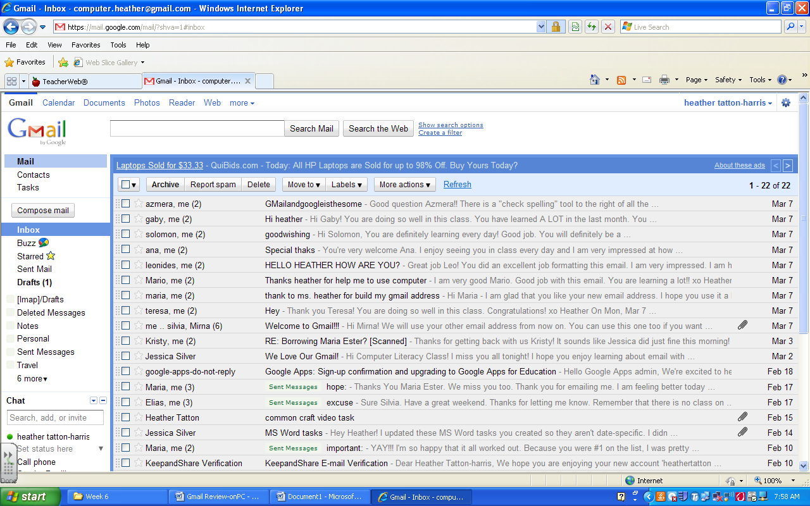

# WRITING AN EMAIL

1 – Click on Compose Mail