Computer Software
Objectives
In this chapter you will:

- Read about what software is.
- Discuss the different types of software that we use in our classroom.
- Learn how to use Windows 7 Operating System Software tools.
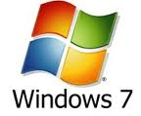
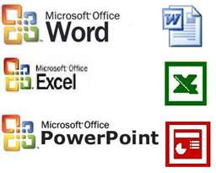

Computer Software Basics
Computer software is often called a program or an application. Software gives your computer instructions to follow so you can complete a task.

Pre-Reading

Discussion

Open each of the following software applications one at a time. Talk about how you can use each one.

- Word
- Excel
- PowerPoint
- Publisher
- Internet Explorer

- To open each program, follow these steps:

- Start Button 2. All Programs 3. Microsoft Office

Vocabulary

Word | Definition

Reading – Introduction to Computer Software

1. Software description

Computer software is often called a program or an application. Software gives your computer instructions to follow so you can complete a task. So what is the difference between Software and Hardware? Remember that Computer Hardware are the parts of the computer that you can touch.

- monitor
- keyboard
- CPU
- Mouse

Computer Software are the programs that give your computer instructions.

2. Many kinds of software

Software companies make many kinds of computer software. Some examples are:

- Operating system software
- Word processing software
- Spreadsheet software
- Presentation software
- Browser software

Each type of software has its own instructions and vocabulary. You need to choose the software that is right for the job you want to do.

To put new software on your computer, you have to INSTALL it. To install new software, you can use a CD or you can download the software from the Internet.

3. Operating system software

When you turn on your computer the first program that starts is the operating system software (OS). On the personal computers in our classroom, the operating system software is Microsoft Windows 7.

Every computer needs operating system software. The operating system works like the director of your computer. It directs the action between the software, the hardware and the processor.

The first screen you see when the computer starts up is your desktop. The desktop is part of the operating system. The operating system controls the icons and folders on the desktop.
DESKTOP

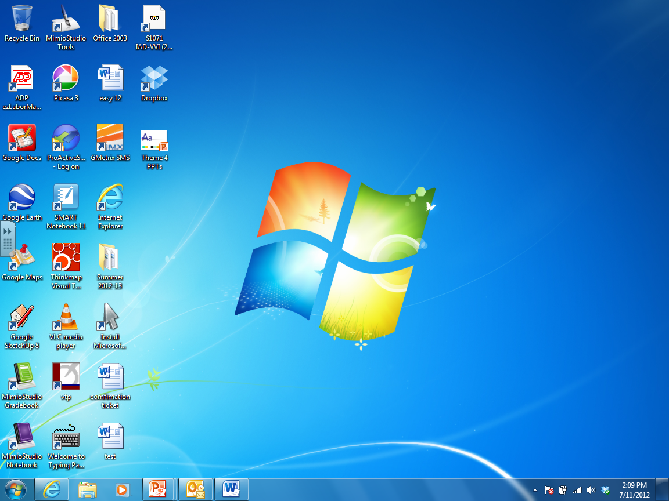
Icons

Start Menu Button

4. Microsoft Office software

The Microsoft Company makes the most popular software for personal computers. The man who created Microsoft is Bill Gates.

The Microsoft software products are often sold together in a package called Microsoft Office.

- Microsoft Word is word processing software. It is used for typing papers, letters, resumes, tables, schedules and many other kinds of documents.

- Microsoft Excel is used for organizing information and doing calculations such as budgets and business plans.

- Microsoft PowerPoint is used to create slideshow presentations with pictures and sounds.
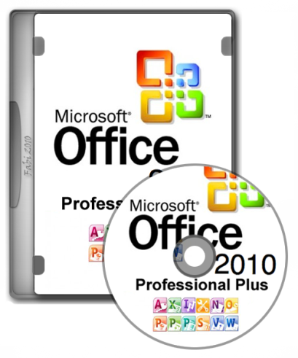

5. Browser software

Browser software lets you view pages on the World Wide Web. Internet Explorer and Mozilla Firefox are popular brands of browser software. If you do not have browser software like Internet Explorer on your computer, you cannot get to the Internet!

Internet Explorer
Mozilla Firefox

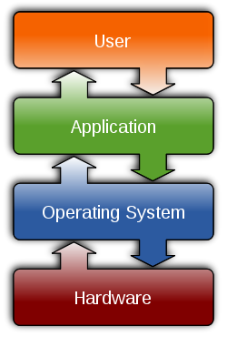
The picture to the left shows how hardware, the operating system, software applications and a computer user work together. Talk about this picture with your partner. Does it make sense to you? Can you draw a better picture?

Operating System (OS) Tools – Windows 7

Minimize, Restore/Maximize, and Close Buttons
There are three buttons on the top right corner of all windows: minimize, restore/maximize, and close.

- When you click on the minimize button, you are moving the window to your Task Bar.
- When you click on the restore down/maximize button, your window will either get smaller or bigger.
- When you click on the close button, you will close the window.

Close button
Minimize

Restore down/ Maximize

Resizing your Window
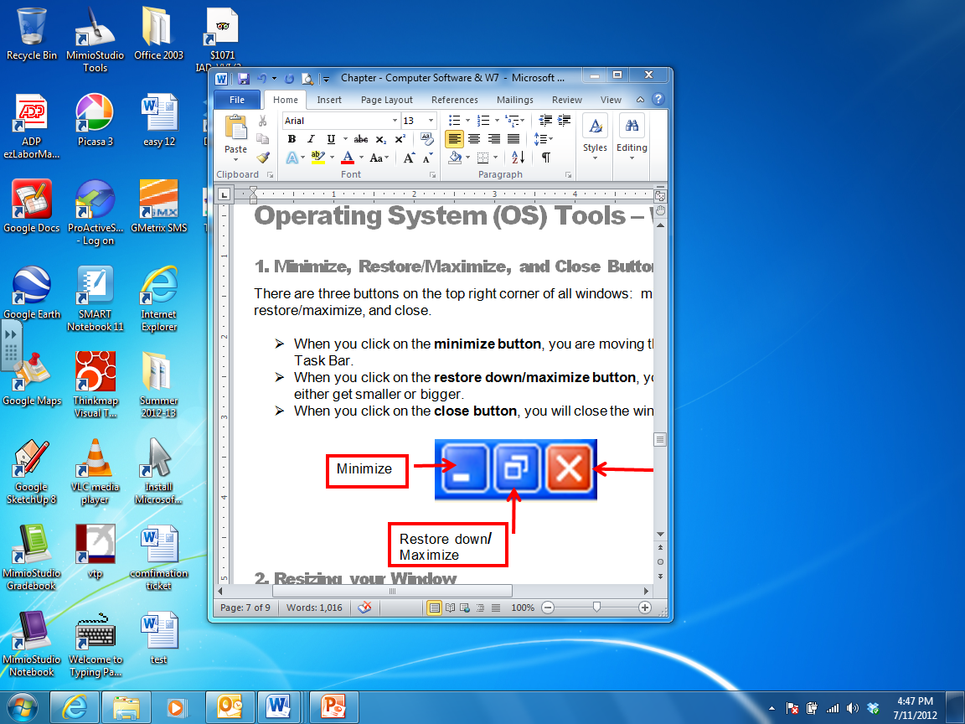
When your window is NOT maximized, you can change its size and shape. Put your cursor on a corner of the window, click and drag the window to make it smaller or bigger.

Your Task Bar
Your Task Bar shows you what programs you have open.
Task Bar

Icons
To open a program using an Icon, always be sure to double-click on the picture (not the words!).
Icons

Switching between Programs and Windows
There are two ways to switch between programs and windows.

- You can use your Task Bar to click on what you want to see.

Task Bar

- You can use your keyboard – and press at the same time – the ALT key and the Tab key (Alt +Tab).

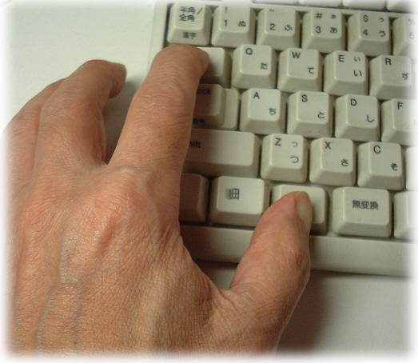

Task 1 – Operating System Tools Practice

Directions:

In this exercise you will practice some operating system tools that we have learned so far. Fallow these instructions carefully!

- Open Internet Explorer
- Click on the Minimize button. Where does your window go? ___________________________________________________________
- Find your Internet Explorer window on your Task Bar and click on it.
- Click on the Restore/Maximize button.
- Resize your window by putting your cursor on a corner of the window. Click, hold and drag your mouse to change the shape of the window.
- Maximize your window.
- Restore your window. Did it go back to the shape that you created? ___________________________________________________________
- Minimize all of your windows so that you only see the desktop.
- How many tasks do you have on your task bar? ___________________________________________________________
- Click once on any icon on your desktop. What happens when you click once? ___________________________________________________________
- Click two times SLOWLY on the words underneath an icon. What happens? ___________________________________________________________
- Double click, very fast; on an icon (be sure to click on the icon or picture!). What happens? ___________________________________________________________
- Use ALT + Tab to switch between programs.

Task 1 – Review Questions

Part 1: Discuss what each of these software programs is used for

- Word
- Excel
- PowerPoint
- Publisher
- Internet Explorer

Part 2: Point to and talk about how each of the following tools works

- Minimize button
- Restore / Maximize button
- Close button
- Task Bar
- Icons
- Resizing your window
- Switching between programs.

Part 3: Answer the following questions

- How do you put software on your computer?

__________________________________________________________________

__________________________________________________________________

- What does Operating System (OS) software do? Which OS program do we use in our class?

__________________________________________________________________

__________________________________________________________________

__________________________________________________________________

- What is the desktop?

__________________________________________________________________

