Computer Hardware

Objectives

In this chapter you will:

1. Read and discuss the names of some important computer hardware components
2. Read and discuss the functions of these components
3. 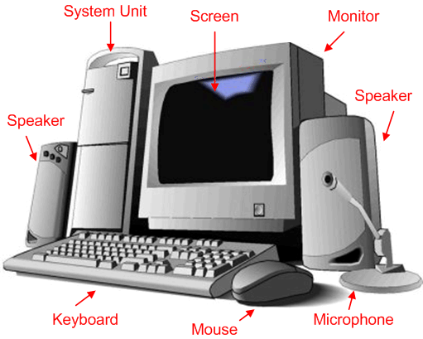Identify input and output devices

**CPU Case**

Computer Hardware Basics

Hardware includes all the parts of the computer that you can see and touch.

# Pre-Reading

## Discussion

With a partner, try to DEFINE and POINT TO each of the following hardware components.

* Mouse
* CPU case (**C**entral **p**rocessing **u**nit)
* Hard drive
* Processor (brain)
* Cables
* Speakers
* Headset
* Keyboard
* Monitor & screen
* Printer
* Laptop or Notebook

## 

## Vocabulary

| **Word** | **Definition** |
| --- | --- |
| Component | A part of a computer system. |
| Function | What something does; it’s purpose. |
| To plug into | To fit one object into another. |
| Device | A part of a computer system |

# Reading – Introduction to Computer Hardware

Hardware includes the parts of the computer that you can see and touch. Companies such as Dell, Gateway, hp, Asus, and many other companies make hardware for personal computers.

MCj03968580000[1]Personal computers are usually called PC’s. There are two types of PCs: 1) Desktops and 2) Laptops or Notebooks. Desktop PC’s are large and sit on a desk or table. We use desktop PC’s in this class. Laptops (sometimes called Notebooks) are small and portable.

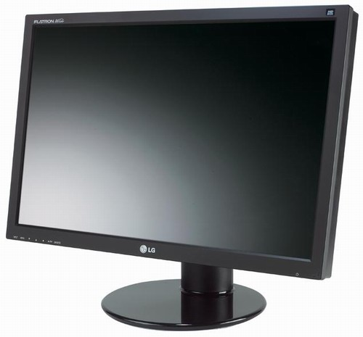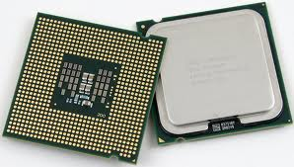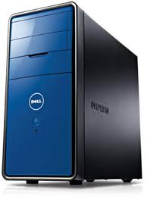There are five important parts to any PC:

* + 1. Monitor
    2. 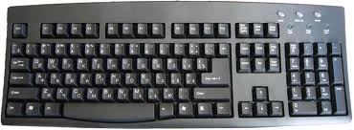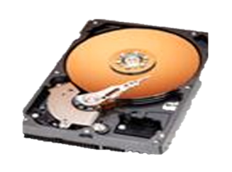CPU case with the processor and hard drive
    3. 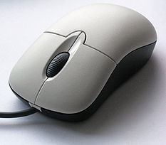Keyboard
    4. Mouse
    5. 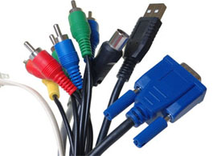Cables



The **monitor** looks like a television set. It contains the screen. Monitors come in different sizes. Today most monitors are flat and take up very little space.

MONITOR



SCREEN

The **CPU case** is the tower or box you see that is connected to your monitor. **CPU** stands for **C**entral **P**rocessing **U**nit. The **CPU case** contains two very important components: the Hard Drive and the Processor.

**PROCESSOR**

**HARD DRIVE**



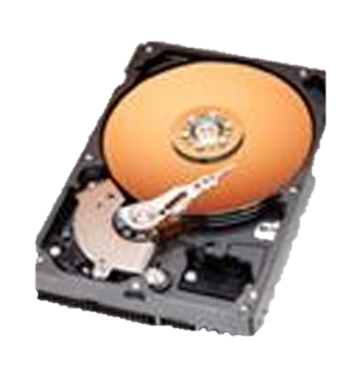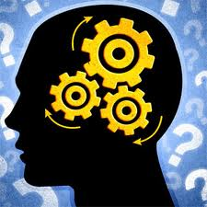You cannot see the **processor** because it is inside your computer. The processor is one of the most important parts of your computer because it where the calculations take place. Intel and AMD are the two companies that make most processors. Many people call the processor the “brains” of the computer.

The **hard drive** is also inside the CPU case. The hard drive is where your software applications are stored. It is also the place where your documents are stored when you save them. You save your work on a hard drive.

The computer **keyboard** is the same as a typewriter keyboard. A keyboard contains over 100 different keys. There are keys for letters, numbers and symbols. On some keyboards there is a 10 key- pad for entering numbers and calculations. Can you find the 10-key pad on your keyboard?

Insertion PointThe **mouse** controls the cursor. It is the tool that lets you select text and graphic items displayed on the computer screen. The cursor can appear in different forms depending on the job you are doing. Sometimes the cursor looks like a flashing line. This is called the insertion point – it tells you where you can insert letters and words. Sometimes the cursor looks like a pointer (arrow) and other times it looks like a hand or a cross. Below are three examples of what the cursor can look like.

|  |
| --- |
| Insertion Point for typing your words.    Hand that you will see on the internet when you are on a hyperlink.  The normal pointer arrow that you will see on the desktop. |
|  |

**Cables** connect the components of your computer to each other. Cables plug into **ports** on the monitor, CPU case and keyboard.

# Ports on the CPU case:

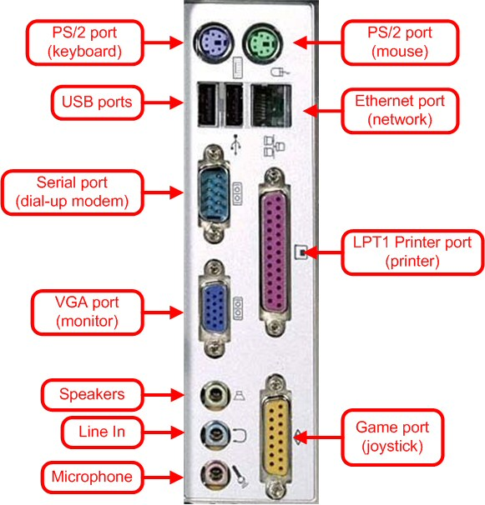

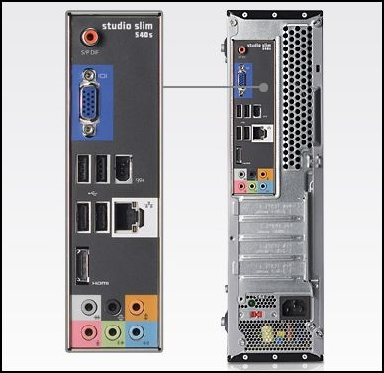

# Task 1 – Fill In The Blanks

1. If you want a small computer that you can carry with you, you should buy a ________________.
2. The monitor contains the ___________________.
3. Inside the CPU case is the _________________ and the hard drive.
4. The ___________ ______________ is where you save your work.
5. The mouse controls the _______________________.
6. Many people call the processor the ______________ of the computer.
7. Cables plug into ________________
8. _______________ connect the components of your computer together.

# Task 2 - Label Each of the Following Computer Hardware



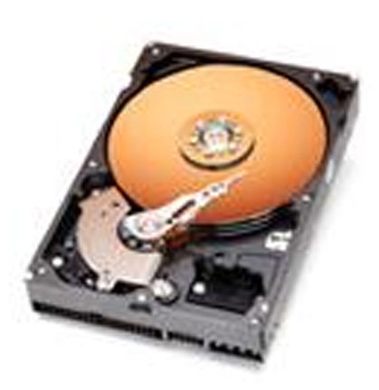

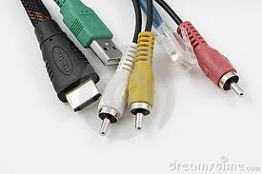

# Task 3 – Define In Your Own Words

|  |  |
| --- | --- |
| 1. What does PC stand for? |  |
| 1. What type of computer do we use in the classroom? |  |
| 1. What type of computer can you carry with you? |  |
| 1. What are five important components of a PC? |  |
| 1. What does CPU stand for? |  |
| 1. What are two important hardware components that you find inside the CPU case? |  |
| 1. What does the processor do? |  |
| 1. What does the hard drive do? |  |
| 1. What are cables used for? |  |

More Computer Hardware

In addition to the basic hardware devices there are a few others you should know.

* 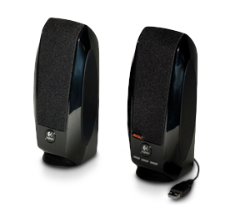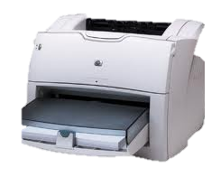**Printer** – a printer creates a hard copy (paper copy) of your work on the computer.
* **Speakers** – speakers are used to play music and sound

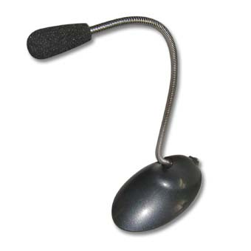

* **Microphone** – you can record your voice into the computer by using a microphone.

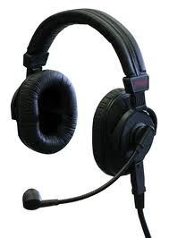

* **Headset** – headsets are like speakers but are used on your ears. Some headsets also have a microphone.
* **1222497007Flash drive** - A flash drive is a device that lets you save your work to a place outside your computer. When you save a file or document on a flash drive you can take it and use it on another computer.

# Task 4 – Discuss with a Partner

1. Are there other hardware components that you know of? What are they?

___________________________________________________________

1. What hardware components have you used before?

___________________________________________________________

1. What components do you want to learn how to use better?

Input and Output

Some computer components provide information that goes **INTO the computer** - these are **INPUT devices**. Some components produce information that comes **OUT of the computer** – these are **OUTPUT devices**. Work with a partner to decide which category the following hardware components fit into.

* Keyboard
* Printer
* Monitor
* Speakers
* Microphone
* Headset

|  |  |
| --- | --- |
| INPUT | OUTPUT |
|  |  |

Input and Output 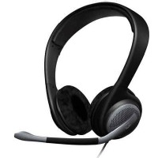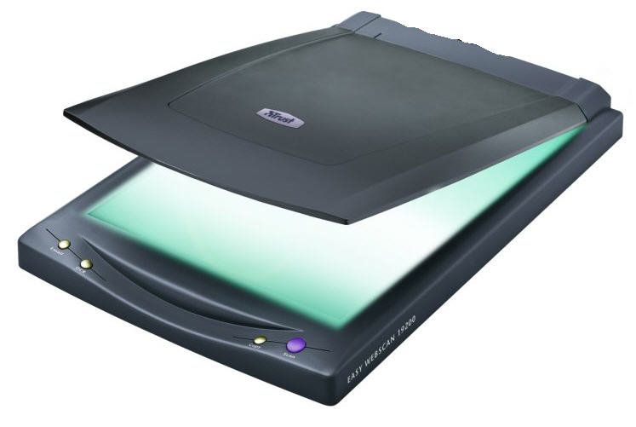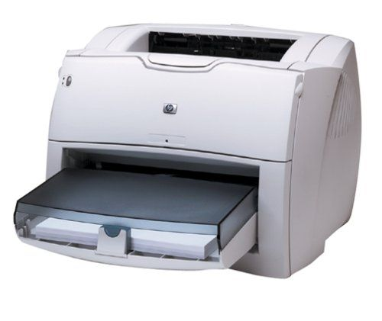Devices

**(OUTPUT DEVICE)**

**(OUTPUT DEVICE)**

**(OUTPUT DEVICE)**

**(INPUT DEVICE)**

**(INPUT DEVICE)**

**(INPUT DEVICE)**

**CPU Case**

**(INPUT DEVICE)**

**(OUTPUT DEVICE)**

**(INPUT - OUTPUT DEVICE)**

**Printer**

**Scanner**

**Headset**